

**BT4016  
Mid-Term Report**

AY21/22 Semester 1

Group 21  
  
Dylan See Keane Loong A0183045J  
Justin Julius Chu Qijie A0183794M  
Mohamad Nurhakiem Bin Mohamd Rasid A0190241R  
Oon Kei Zee Casey A0171354J

**1 Investment Goal** **2**

1.1 Utility Function 2

1.2 Minimizing Semi-variance 2

**2 Optimization of Best Portfolio Holdings** **3**

2.1 Return Estimation 3

2.2 Semi-variance Optimization 4

2.3 Weight Constraints 4

2.4 Sector Constraints 4

2.5 L2 Regularization 4

**3 Comparing Weights Between Best Portfolio (Old Weight) and Optimized Portfolio (New Weights)** **5**

3.1 Observations 6

3.2 Evaluating Performance of Our Two Optimal Portfolios 6

**4 VaR and ES of Best, Worst and Optimized Portfolios** **7**

**5 Back Testing** **8**

**6 Additional Adjustments to Optimized Portfolio** **8**

6.1 Updated News About Stocks in Portfolio 8

6.2 Adjust Portfolio with forward looking expected return and variance covariance matrix 9

6.3 Applying Dividend Discount Model (DDM) to $NXPI 10

6.4 Derive a New Optimal Portfolio Using the New Expected Return and Var-covariance 11

#### 

### 

### **1 Investment Goal**

#### **1.1 Utility Function**

Given the required utility function $U=E(R_{p})-k*stderr(R_{p})^{2}$,  
suppose we only invest in the market portfolio and risk-free asset, and aim to optimally invest 75% of our funds into the market portfolio.

Market portfolio has expected return of 10% and annualized standard error of return of 18%. The risk-free rate is assumed to be 1%.

$E(R_{p}) = 0.25*0.01+0.75*0.1$ $E(R_{p})=0.0775$

$stderr(R_{p})^{2}=0.25^{2}*0+0.75^{2}*0.18$ $stderr(R_{p})^{2 }=0.10125$

Since $\max_{w}U=r_{f}+w[E(R_{m})-r_{f}]-kw^{2}stderr({R_{m}}_{})$, $\frac{dU}{dw}=[E(R_{m})-r_{f}]-2kw*stderr({R_{m}}_{})=0$ $k=\frac{[E(R_{m})-r_{f}]}{2w*stderr({R_{m}}_{})}$ $k=\frac{0.10-0.01}{2*0.75*0.18}=0.33$
  
  
3

Our objective function is then $U=E(R_{p})-0.333*stderr(R_{p})^{2}$,  
Only investing in the market portfolio and risk-free asset gives us a utility of, $U=0.0775-0.333*0.10125=0.04378375$

#### **1.2 Minimizing Semi-variance**

Semivariance is a measurement used to estimate potential downside risk of a portfolio since it only considers observations that are below the mean or target returns. Since this is an aggressive semiconductor growth fund, we are risk-seeking and want to achieve annual returns of 80%.

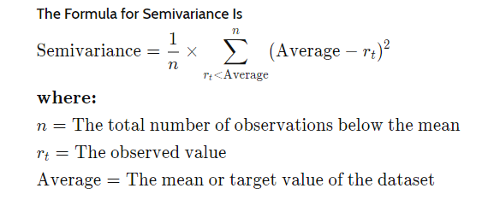

### **2 Optimization of Best Portfolio Holdings**

#### **2.1 Return Estimation**

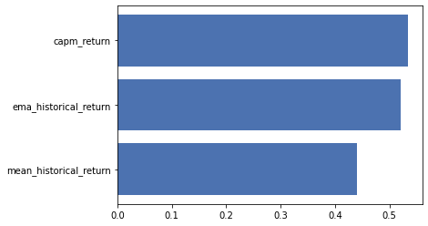

We plot the mean absolute errors for 3 different return methods, and observe that the capm_return is marginally better than the other two methods. We also note that while a higher absolute deviation value indicates higher gains for realised annual returns; It also indicates potentially higher losses. The following steps can be found in detail in the ipynb file.

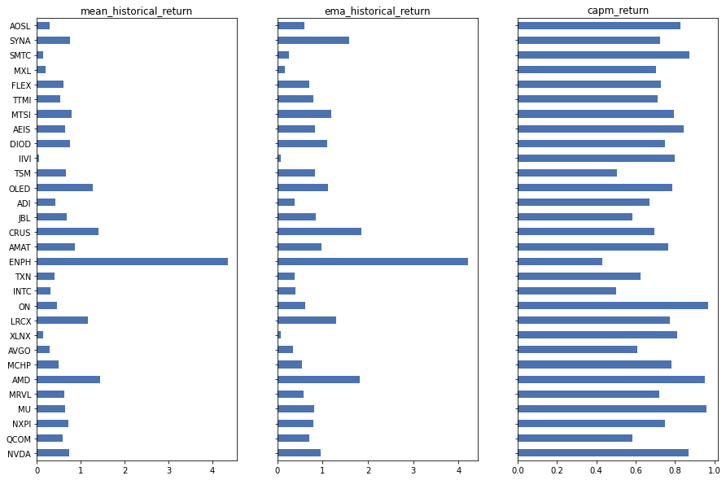

Furthermore, we observe that our capm_returns to be more stable than both of the other methods.

Therefore we use capm_returns to calculate our mu; using a risk free rate of 1% as per instructions.

#### **2.2 Semi-variance Optimization**

Now we optimize our mutual fund holding using the semi-covariance objective function as outlined in qn1. We minimise the portfolio semi-variance (downside risk) with constraints of expected annual returns of 80%.

#### **2.3 Weight Constraints**

Each stock can only have a maximum weight up to and including 25% of our portfolio of stocks.

#### **2.4 Sector Constraints**

Typically we would seek to diversify our sector exposure by setting sector constraints on any particular sector. However, FELAX is a fund that is already heavily engaged in equity securities of firms engaged in the design, manufacture or sale of electronics components. The holding’s sector allocations are 94.67% Technology, 2.72% Industrials, 0.42% Oil & Gas and 0.35% Non Classified Equity. As such we do not set sector constraints.

#### **2.5 L2 Regularization**

We found that after optimization, far too many securities have weights set to 0. This was not optimal as it left us overexposed to certain firms. To further diversify our risk, we implemented L2 regularization at gamma levels 0.1 and 0.9 to reduce overfitting towards certain firms and promote smaller weights.

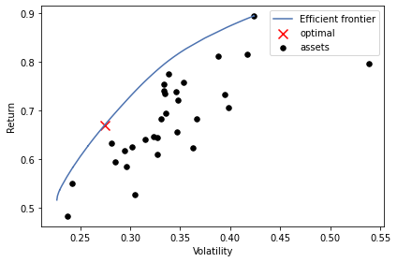

Here we can observe our unconstrained efficient frontier.

### **3 Comparing Weights Between Best Portfolio (Old Weight) and Optimized Portfolio (New Weights)**

| **Ticker** | **Old Weight** | **New Weight $(γ=0.1)$** | **New Weight $(γ=0.9)$** |
| --- | --- | --- | --- |
| NVDA | 0.19696 | 0.02139 | 0.00436 |
| QCOM | 0.06962 | 0.00000 | 0.00000 |
| NXPI | 0.06289 | 0.01669 | 0.03938 |
| MU | 0.06083 | 0.07371 | 0.05114 |
| MRVL | 0.05586 | 0.00000 | 0.00000 |
| AMD | 0.05483 | 0.00000 | 0.00000 |
| MCHP | 0.04945 | 0.09190 | 0.06677 |
| AVGO | 0.04852 | 0.00000 | 0.00000 |
| XLNX | 0.04810 | 0.00000 | 0.00000 |
| LRCX | 0.04748 | 0.12574 | 0.09055 |
| ON | 0.04479 | 0.22137 | 0.21287 |
| INTC | 0.03983 | 0.00000 | 0.00000 |
| TXN | 0.02938 | 0.00000 | 0.00000 |
| ENPH | 0.02927 | 0.04647 | 0.09268 |
| AMAT | 0.02214 | 0.04006 | 0.04917 |
| CRUS | 0.02059 | 0.00000 | 0.00000 |
| JBL | 0.01459 | 0.00000 | 0.00000 |
| ADI | 0.01345 | 0.00000 | 0.00000 |
| OLED | 0.01231 | 0.00000 | 0.00000 |
| TSM | 0.01159 | 0.00000 | 0.00000 |
| IIVI | 0.00983 | 0.00000 | 0.00000 |
| DIOD | 0.00941 | 0.00000 | 0.00000 |
| AEIS | 0.00838 | 0.11390 | 0.12309 |
| MTSI | 0.00703 | 0.02300 | 0.03778 |
| TTMI | 0.00693 | 0.00000 | 0.00000 |
| FLEX | 0.00683 | 0.00000 | 0.02425 |
| MXL | 0.00579 | 0.12363 | 0.12695 |
| SMTC | 0.00548 | 0.10216 | 0.07298 |
| SYNA | 0.00466 | 0.00000 | 0.00000 |
| AOSL | 0.00321 | 0.00000 | 0.00803 |

|  | **New Weight $(γ=0.1)$** | **New Weight $(γ=0.9)$** |
| --- | --- | --- |
| Expected Annual Return | 80.0% | 80.0% |
| Annual Volatility | 34.0% | 34.3% |
| Sharpe Ratio | 2.29 | 2.27 |

#### **3.1 Observations**

We observed that between gamma = 0.1 and 0.9, at 0.1, we were able to marginally reduce our annual volatility without reducing our expected annual return, while slightly reducing the number of firms with 0 weight. It also increases our Sharpe ratio.

#### **3.2 Evaluating Performance of Our Two Optimal Portfolios**

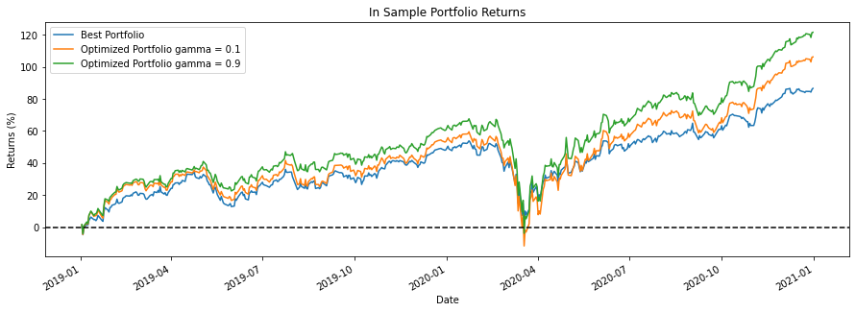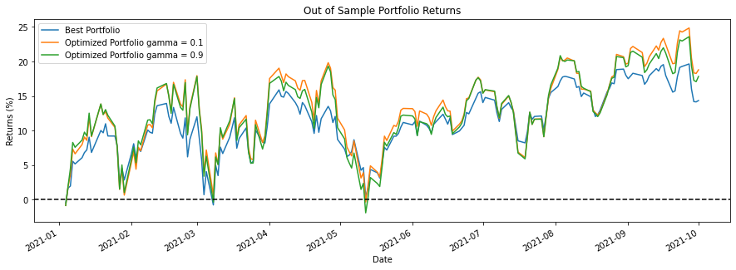

From the plot of in-sample returns, our gamma = 0.9 portfolio outperforms our gamma = 0.1 portfolio. However, if we observe the plot of out of sample returns, our gamma = 0.1 marginally outperforms our gamma = 0.9 portfolio. Since both optimized portfolios outperform the benchmark we can conclude that some regularization is necessary as too many 0 weights leads to overfitting and will not be able to generalize to new data; however we can also conclude that we should not use a gamma value too high as it may lead to underfitting our data and will not allow our model to make useful predictions. **Therefore we conclude the model with gamma = 0.1 to be optimal.**

### **4 VaR and ES of Best, Worst and Optimized Portfolios**

The VaR for the respective portfolios are as follows:

| **Date** | | **VaR (95%) Best Portfolio (FELAX)** | **VaR (95%) Worst Portfolio (BFOCX)** | **VaR (95%) Optimal Portfolio of FELAX** |
| --- | --- | --- | --- | --- |
| 2020-12-31 | Historical Simulation | -212975.30 | -217608.95 | -346381.99 |
| Parametric Simulation | -215792.83 | ​​-213659.74 | -290593.07 |
| 2020-09-30 | Historical Simulation | -212975.30 | -202808.60 | -346381.99 |
| Parametric Simulation | -211237.80 | -208846.84 | -285533.70 |
| 2020-04-30 | Historical Simulation | -208920.39 | -208528.94 | -314375.05 |
| Parametric Simulation | -209416.19 | -205940.43 | -278220.03 |
| 2020-01-31 | Historical Simulation | -119112.74 | -144600.26 | -206664.89 |
| Parametric Simulation | -104659.78 | -119302.75 | -136675.77 |

We observe that since our portfolio garners higher returns, the VaR of our portfolio increases slightly. However, we acknowledge that this is a tradeoff of having a portfolio with a higher return.

The expected shortfalls for our respective portfolios are as follows:

| **Date** | | **ES (95%) Best Portfolio (FELAX)** | **ES (95%) Worst Portfolio (BFOCX)** | **ES (95%) Optimal Portfolio of FELAX** |
| --- | --- | --- | --- | --- |
| 2020-12-31 | Historical Simulation | -0.000739 | 0.00159 | 0.00259 |
| Parametric Simulation | 0.00455 | 0.00863 | 0.00560 |
| 2020-09-30 | Historical Simulation | -0.000120 | 0.000478 | 0.00183 |
| Parametric Simulation | 0.00412 | 0.00842 | 0.00478 |
| 2020-04-30 | Historical Simulation | -0.00114 | -0.00107 | 0.00104 |
| Parametric Simulation | 0.00350 | 0.00414 | 0.00454 |
| 2020-01-31 | Historical Simulation | -0.000946 | -0.00264 | 0.00209 |
| Parametric Simulation | 0.00413 | 0.00546 | 0.00490 |

### **5 Back Testing**

We conducted backtesting methods using the Bernoulli Test, Z-score Test, and Independence test.

We first check the number of times each portfolio will exceed their respective VaRs. Note that for all of these portfolios, the expected number of failures is **12.65**.

|  | **Simulation Type** | **Best Portfolio** | **Worst Portfolio** | **Optimal Portfolio** |
| --- | --- | --- | --- | --- |
| Comparing Statistics | Historical Simulation | 20 | 19 | 20 |
| Parametric Simulation | 21 | 21 | 23 |
| Bernoulli Test  p-value | Historical Simulation | 0.00887 | 0.03 | 0.0168 |
| Parametric Simulation | 0.0167 | 0.00887 | 0.00219 |
| Z-Score Test  p-value | Historical Simulation | 0.008005 | 0.008005 | 0.00141 |
| Parametric Simulation | 0.008005 | 0.008005 | 0.00141 |
| Independence Test | Historical Simulation | Independent | Independent | Independent |
| Parametric Simulation | Independent | Independent | Independent |

We observe that all three portfolios have around 18-23 failures using both the parametric and historical simulation and do not have much deviation between them. All of the values fall within the 5% significance value for both the Z-score test and Bernoulli test and thus we will reject all null hypotheses and conclude that the VaR that we have calculated is a good estimate for all three portfolios. All the portfolios also show independence for the independence tests.

### **6 Additional Adjustments to Optimized Portfolio**

#### **6.1 Updated News About Stocks in Portfolio**

Firstly, our optimized portfolio is heavily focused on NVIDIA (NVDA). NVIDIA has experienced a great boom in recent years (it has had more than a 1000% boom since 2016) due to the boom in GPUs and gaming hardware, which is continuing to rise given the surge in gaming during the COVID-19 era. It might be a wise decision to slightly increase the weight for our optimal portfolio on NVIDIA. Given that the weights of our portfolio is limited to 0.25, increasing the weight of the stock to the maximum of 0.25 might give us a good chance of beating all of the other portfolios.

Since our optimised portfolio has a weight of > 0.2 on ON (ON Semiconductors), it might be wise to tweak this weight given that ON has sunk slightly in October 2021. Adjusting the weight of ON to be slightly lower will be a good idea to avoid the slump that starts in September 2021.

Enphase Energy Inc, ENPH, which deals in solar energy, has had a big increase in the past year. They have also just announced their Brazil expansion. The price of the security is likely to rise, hence it would be a relatively good idea to sell some of it before the price falls to correct itself. On a larger scale, currently oil prices are still expected to increase, with corrections happening occasionally. As a competitor in energies, there is a high likelihood that securities in the renewable energy industry are also likely to increase. Currently its weight sits at approximately 0.05, whether or not its weight should be increased depends on how much risk we are willing to take with ENPH’s expansion into a new market.

#### **6.2 Adjust Portfolio with Forward Looking Expected Return and Variance Covariance Matrix**

For this question we wish to optimize our expected returns and variance covariance matrix to be forward looking. For our purposes we compare how different risk models predict an out of sample covariance matrix; and how well different return models predict out of sample returns. (Code in ipynb file)

**Forward looking expected return**

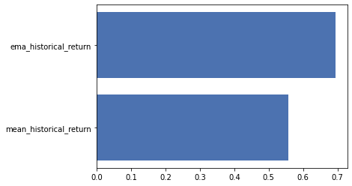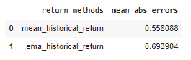

We know that by default equal weight is applied to all returns across the sample period; mean historical returns may not be able to accurately account for the diminishing predictability of older data, we therefore want to determine if other methods such as exponentially weighted returns could return a higher performance. From the above plot and table, we can observe that exponentially weighted returns are a significant improvement from mean historical returns with higher absolute deviations.

**Forward looking variance covariance matrix**

We plot the covariance matrix of the in sample (above) and out of sample (below) to visually observe that the sample covariance matrix does not appear to capture many new features in the later half of the time period. (Appendix 1.1)

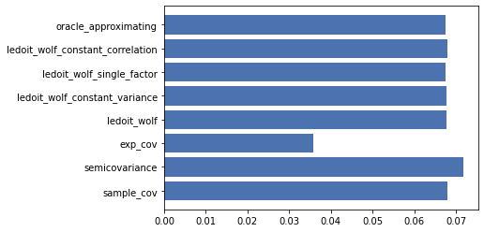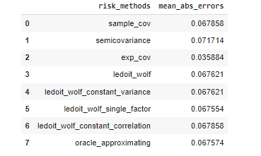

We observe that the exponential covariance matrix is a far better estimator of future variance vs the other models as it has a much lower mean absolute error.

Now we compare the exponential covariance matrix (above) to the out of sample covariance matrix (below, same as before) and can visually observe that it seems to more accurately capture new features than before. (Appendix 1.2)

#### **6.3 Applying Dividend Discount Model (DDM) to $NXPI**

NXPI has paid out quarterly dividends starting from Q4 2018.

| **Date** | **Quarterly Dividend Payout per Share** |
| --- | --- |
| Q1 - Q3 2021 | $0.5625 |
| Q1 - Q4 2020 | $0.375 |
| Q3 - Q4 2019 | $0.375 |
| Q1 - Q2 2019 | $0.25 |

| **Market price of $NXPI at 01/04/2021 (Q2)** | $208.08 |
| --- | --- |
| **Market price of $NXPI at 15/09/2021 (Q3)** | $212.34 |

From the historical dividend payouts, we can estimate that the annual dividend growth rate g is,

$0.25*({1+g)}^{3*4}=0.5625$

$g=0.069913194$

Therefore theoretical valuation of NXPI $P_{2021,Q3}$ is,

$P_{2021, Q3}=P_{2021, Q2}*(1+g)$

$P_{2021,Q3}=208.08*(1+0.069913194)$

$P_{2021,Q3}=222.627537408$

Expected return = $\frac{P_{2021,Q3}}{Real Market Price at 15/09/2021}=\frac{222.627537408}{212.34}=1.04844842$

This leads us to conclude that the expected return of NXPI is greater than its required return.

E[ $R_{NXPI}]$ > $r_{NXPI}$. Therefore, we can improve our portfolio by increasing the weight of NXPI until the point E[ $R_{NXPI}]$ = $r_{NXPI}$.

#### **6.4 Derive a New Optimal Portfolio Using the New Expected Return and Var-covariance**

Using the exponentially weighted returns and exponential covariance matrix from 6.2, along with a new time period up to end September 2021, this new optimal portfolio is able to achieve the same expected annual returns as the previous optimal portfolio (from qn 3) but with lower volatility and higher Sharpe ratio.

|  | **Optimal portfolio from qn 3** | **New optimal portfolio** |
| --- | --- | --- |
| Expected Annual Return | 80.0% | 80.0% |
| Annual Volatility | 34.0% | 26.1% |
| Sharpe Ratio | 2.29 | 2.99 |

#### 

**APPENDIX:**

<https://www.nasdaq.com/articles/will-nvidia-be-a-trillion-dollar-stock-by-2025-2021-10-15>

<https://www.nasdaq.com/articles/on-semiconductor-corp.-on-stock-sinks-as-market-gains%3A-what-you-should-know-2021-10-13>

<https://finance.yahoo.com/news/enphase-energy-announces-expansion-brazil-120000116.html>

<https://finance.yahoo.com/news/crude-oil-price-confirmation-closing-020701535.html>

https://finance.yahoo.com/news/enphase-energy-inc-enph-going-154127181.html

**Appendix 1.1**

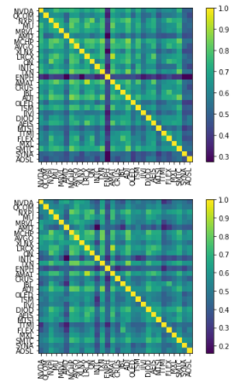

**Appendix 1.2**

